Marks claimed:

Indoor section made using Probuilder and Unity primitives (25%)

Outdoor section made using the Terrain editor, including textures, trees, grass and water (25%) Textures on the indoor section (5%)

With Normal Maps (5%)

Direct light sources beyond the Directional Light (5%)

Use of emissive materials (5%)

Particle Systems (10%)

Simple, single state animation (5%)

Use of multiple cameras (10%)

Use of NavMesh Agents (5%)

Total marks claimed: 100%

The Houses:

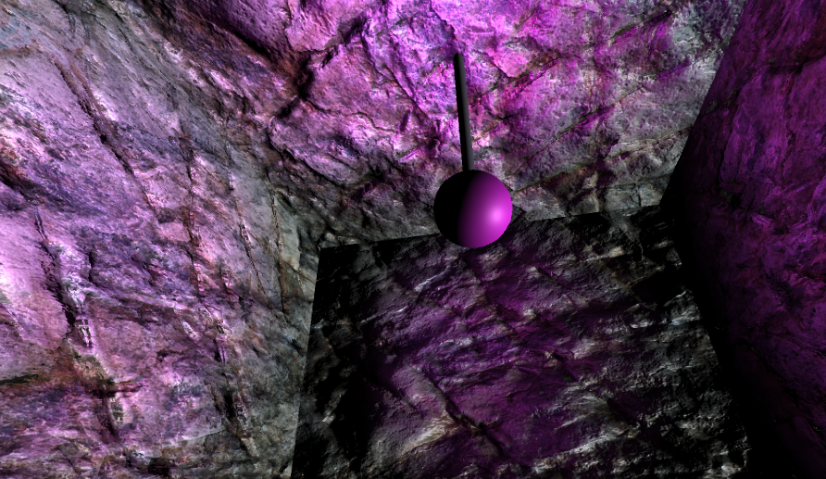

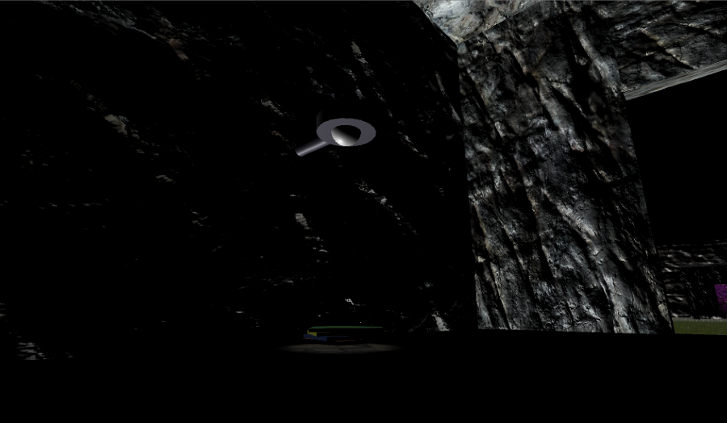

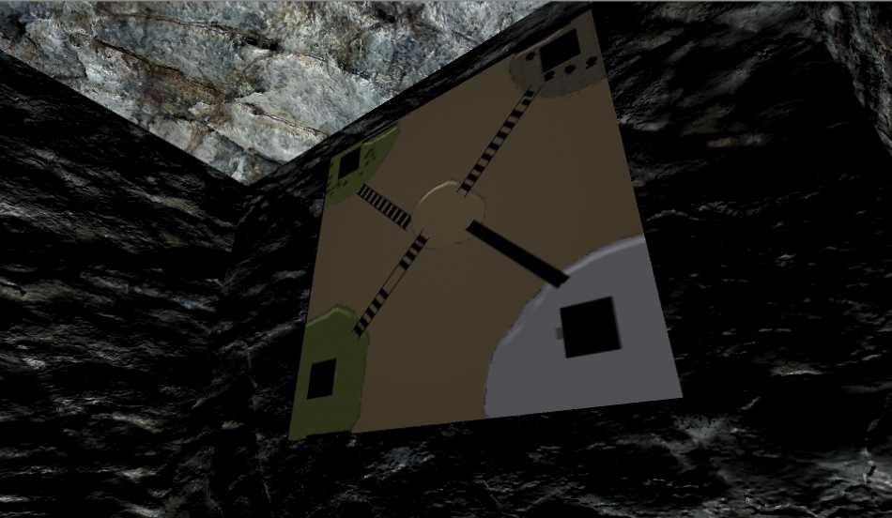

The game has four houses, two of them have light, one has spot light on books, and the other one is point light at mid. The third house a screen with minimap. All walls of house used normal map and textures, the monitor is and emissive material.

Terrain:

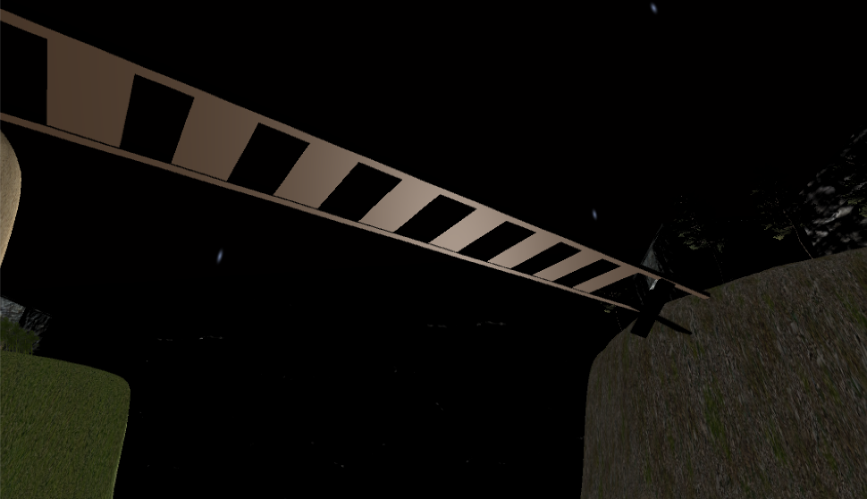

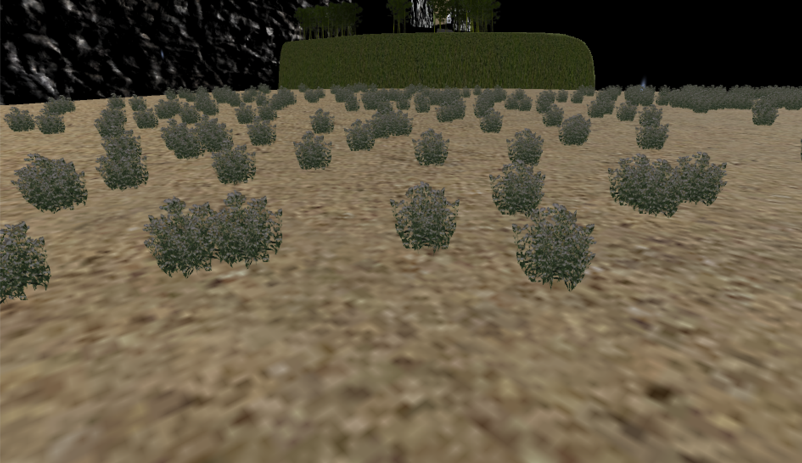

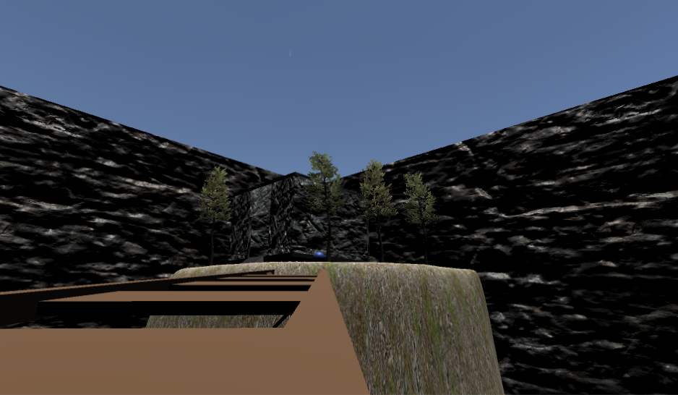

The terrain has day and night system, with tree and grass, also wind and water. I create a particle system use for raining (I setting it bigger, it is hard to see).

The enemy:

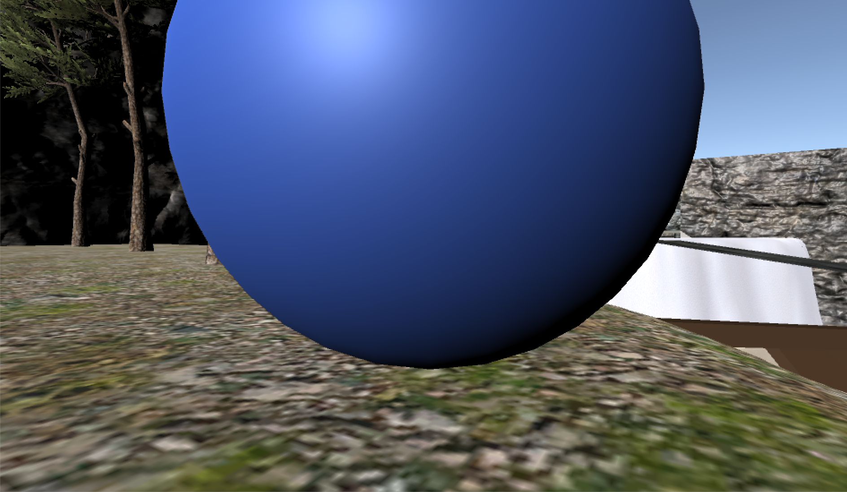

I setting an enemy (and alien looks like a blue ball) around a house, it has a NavMesh on, and can follow player around the house.